Rat in a Maze
Problem Statement: Given a grid of dimensions n x n. A rat is placed at coordinates (0, 0) and wants to reach at coordinates (n-1, n-1). Find all possible paths that rat can take to travel from (0, 0) to (n-1, n-1). The directions in which rat can move are 'U' (up) , 'D' (down) , 'L' (left) , 'R' (right).
The value 0 in grid denotes that the cell is blocked and rat cannot use that cell for travelling, whereas value 1 represents that rat can travel through the cell. If the cell (0, 0) has 0 value, then mouse cannot move to any other cell.
Input: n = 4 , grid = [ [1, 0, 0, 0] , [1, 1, 0, 1], [1, 1, 0, 0], [0, 1, 1, 1] ]
Output: ["DDRDRR" , "DRDDRR"]
Explanation: The rat has two different path to reach (3, 3).
The first path is (0, 0) => (1, 0) => (2, 0) => (2, 1) => (3, 1) => (3, 2) => (3, 3).
The second path is (0,0) => (1,0) => (1,1) => (2,1) => (3,1) => (3,2) => (3,3).
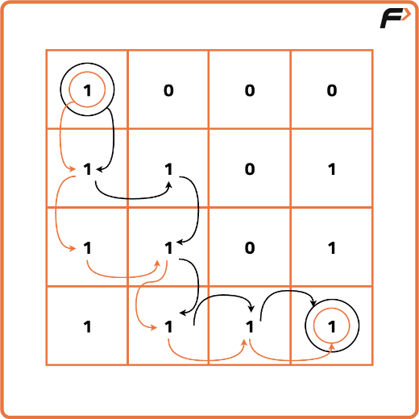
Input: n = 2 , grid = [[1, 0] , [1, 0]]
Output: []
Explanation: There is no path that rat can choose to travel from (0,0) to (1,1).

Algorithm
Since the rat need to find all the paths to reach destination it should explore the maze step by step, trying every possible direction at each junction. If it reaches a dead end or an already visited cell, it backs up to the last decision point and tries another route. This way, it explores all possible paths from the start to the destination without missing any options. By marking cells as visited when moving forward and unmarking them when stepping back, the rat avoids infinite loops and ensures every path is explored exactly once.
- Start at the source(0,0) with an empty string and try every possible path i.e upwards(U), downwards(D), leftwards(L) and rightwards(R).
- As the answer should be in lexicographical order so it's better to try the directions in lexicographical order i.e (D,L,R,U)
- Declare a 2D-array named visited because the question states that a single cell should be included only once in the path,so it's important to keep track of the visited cells in a particular path.
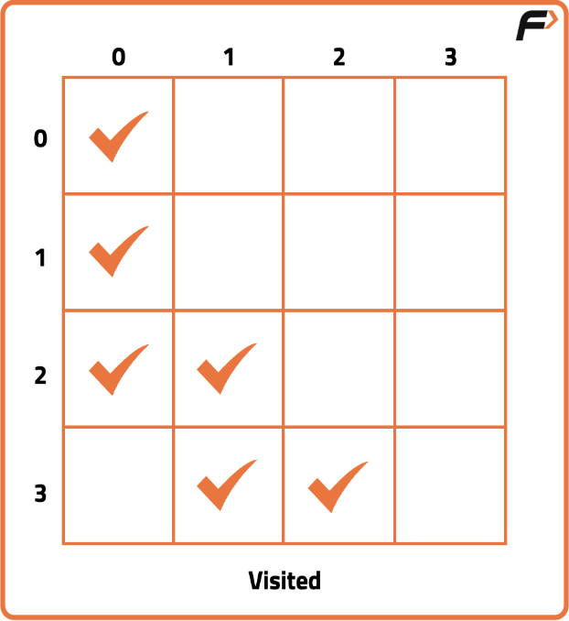
- If a cell is in path, mark it in the visited array. Also keep a check of the “out of bound” conditions while going in a particular direction in the matrix.
- Whenever we reach the destination(n,n), store the path in your answer and backtrack to find more available paths.
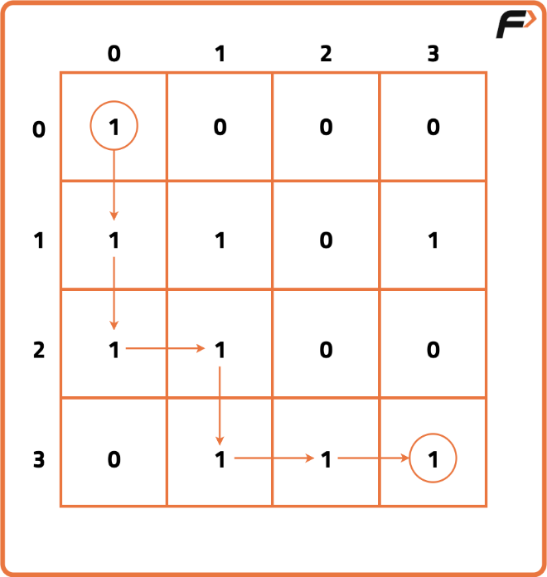
- While getting back, keep on unmarking the visited array for the respective direction. Also check whether there is a different path possible while getting back and if yes, then mark that cell in the visited array.
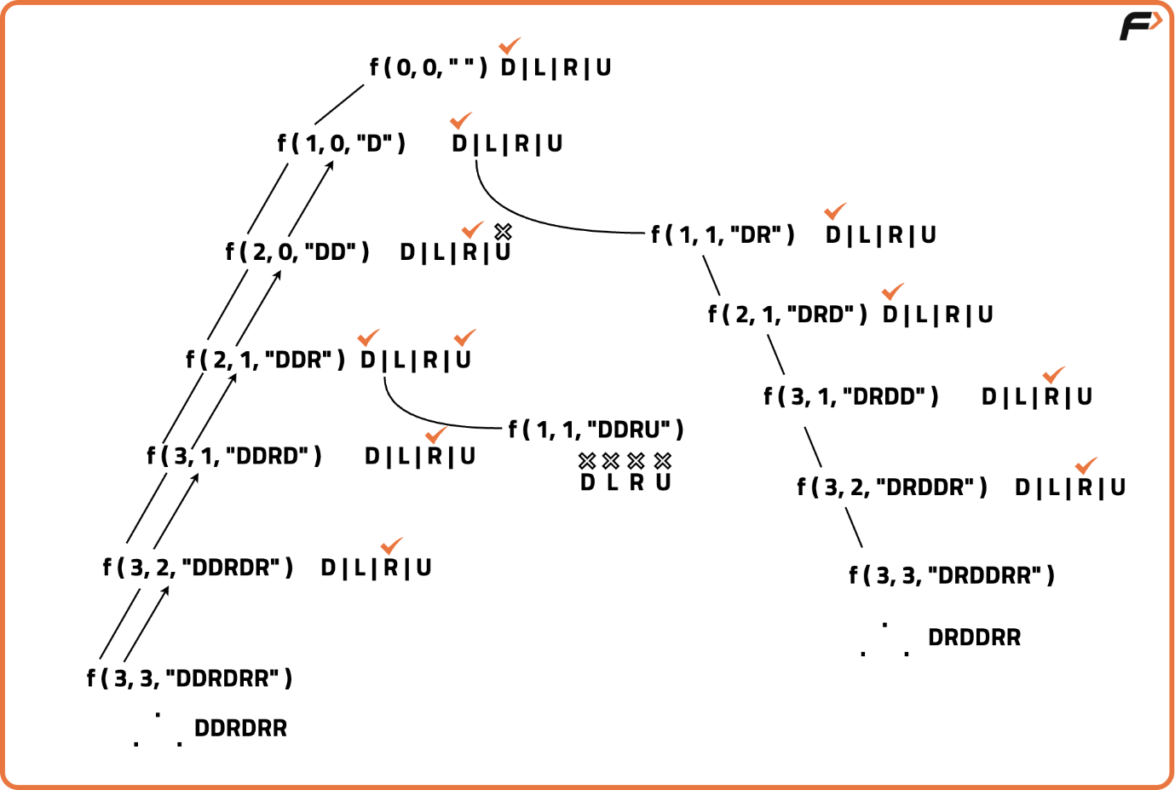
Code
CppJavaPythonJavascript
import java.util.*;

// Class to solve the Rat in a Maze problem
class Solution {

// Function to check if the cell is within maze and valid to move
boolean isSafe(int x, int y, int n, int[][] maze, int[][] visited) {
return (x >= 0 && x < n && y >= 0 && y < n &&
maze[x][y] == 1 && visited[x][y] == 0);
}

// Function to solve maze using backtracking
void solve(int x, int y, int n, int[][] maze, int[][] visited,
String path, List<String> res) {

// If destination reached, store the path
if (x == n - 1 && y == n - 1) {
res.add(path);
return;
}

// Mark the cell visited
visited[x][y] = 1;

// Try moving Down
if (isSafe(x + 1, y, n, maze, visited)) {
solve(x + 1, y, n, maze, visited, path + "D", res);
}
// Try moving Left
if (isSafe(x, y - 1, n, maze, visited)) {
solve(x, y - 1, n, maze, visited, path + "L", res);
}
// Try moving Right
if (isSafe(x, y + 1, n, maze, visited)) {
solve(x, y + 1, n, maze, visited, path + "R", res);
}
// Try moving Up
if (isSafe(x - 1, y, n, maze, visited)) {
solve(x - 1, y, n, maze, visited, path + "U", res);
}

// Backtrack: unmark cell as visited
visited[x][y] = 0;
}

// Main function to find all paths
List<String> findPath(int[][] maze, int n) {
List<String> res = new ArrayList<>();
int[][] visited = new int[n][n];
if (maze[0][0] == 1) {
solve(0, 0, n, maze, visited, "", res);
}
return res;
}
}
Complexity Analysis
Time Complexity: O(4^(N*N)),, because on every cell we need to try 4 different directions.
Space Complexity: O(N*N), additional space for visited array and maximum Depth of the recursion tree(auxiliary space).

